Vocabulary: Effectiveness vs Efficiency

These are two “buzzwords” that are often used by CEOs in describing the performance of their businesses.

Effective (adj.) – adequate to complete a purpose or achieve the expected result
Effectiveness (noun) – the degree to which something is successful in producing a desired result (a measurement of “success”)

Efficient (adj.) – performing in the best manner – minimizing resources (time, energy, money)
Efficiency (noun) – the degree to which resources are minimized to produce a desired result

“Effectiveness is doing/producing the correct things, efficiency is doing/producing the things correctly.”

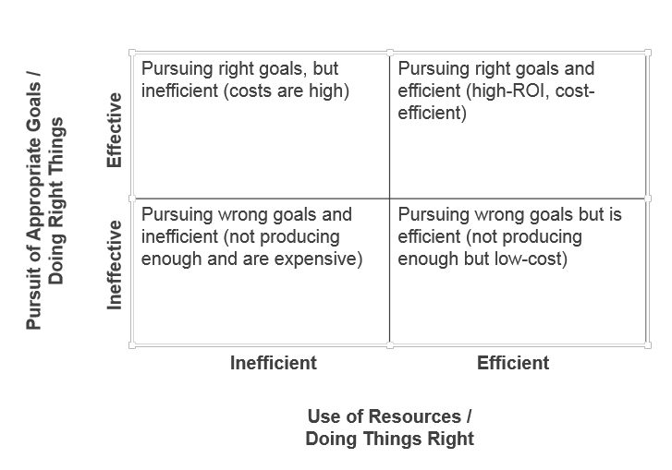

Overall Equipment Effectiveness (OEE) = Availability x Performance x Quality
or: Availability x Productivity x Quality
OEE is a metric to indicate the current status of a manufacturing process.
The global target/reference = 85%

